**PIZZA SALES SQL QUERIES**

**A. KPI’s**

**1. Total Revenue:**

SELECT SUM(total_price) AS Total_Revenue FROM pizza_data;

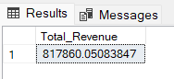

**2. Average Order Value**

SELECT (SUM(total_price) / COUNT(DISTINCT order_id)) AS Avg_order_Value FROM pizza_data

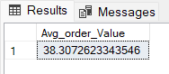

**3. Total Pizzas Sold**

SELECT SUM(quantity) AS Total_pizza_sold FROM pizza_data

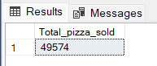

**4. Total Orders**

SELECT COUNT(DISTINCT order_id) AS Total_Orders FROM pizza_data

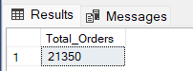

**5. Average Pizzas Per Order**

SELECT CAST(CAST(SUM(quantity) AS DECIMAL(10,2)) /

CAST(COUNT(DISTINCT order_id) AS DECIMAL(10,2)) AS DECIMAL(10,2))

AS Avg_Pizzas_per_order

FROM pizza_data

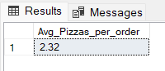

**B. Daily Trend for Total Orders**

SELECT TO_CHAR(order_date, 'Day') as order_day,COUNT(DISTINCT order_id) as total_orders from pizza_data

GROUP BY TO_CHAR(order_date, 'Day')

***Output:***

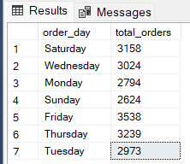

**C. Monthly Trend for Orders**

SELECT TO_CHAR(order_date, 'Month') as order_day,COUNT(DISTINCT order_id) as total_orders from pizza_data

GROUP BY TO_CHAR(order_date, 'Month')

***Output***

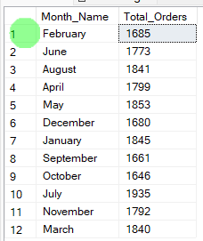

**D. % of Sales by Pizza Category**

SELECT pizza_category, CAST(SUM(total_price) AS DECIMAL(10,2)) as total_revenue,

CAST(SUM(total_price) * 100 / (SELECT SUM(total_price) from pizza_data) AS DECIMAL(10,2)) AS PCT

FROM pizza_data

GROUP BY pizza_category

***Output***

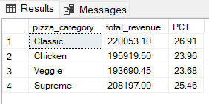

**E. % of Sales by Pizza Size**

SELECT pizza_size, CAST(SUM(total_price) AS DECIMAL(10,2)) as total_revenue,

CAST(SUM(total_price) * 100 / (SELECT SUM(total_price) from pizza_data) AS DECIMAL(10,2)) AS PCT

FROM pizza_data

GROUP BY pizza_size

ORDER BY pizza_size

***Output***

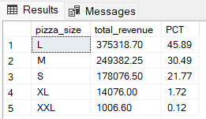

**F. Total Pizzas Sold by Pizza Category**

SELECT pizza_category, SUM(quantity) as Total_Quantity_Sold

FROM pizza_data

WHERE MONTH(order_date) = 2

GROUP BY pizza_category

ORDER BY Total_Quantity_Sold DESC

***Output***

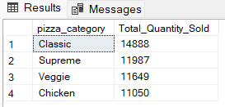

**G. Top 5 Pizzas by Revenue**

SELECT pizza_name,sum(total_price)as total_revenue from pizza_data

GROUP BY pizza_name

ORDER BY total_revenue desc

limit 5

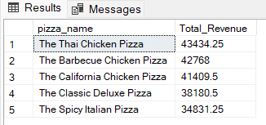

**H. Bottom 5 Pizzas by Revenue**

SELECT pizza_name,sum(total_price)as total_revenue from pizza_data

GROUP BY pizza_name

ORDER BY total_revenue asc

limit 5

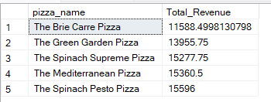

**I. Top 5 Pizzas by Quantity**

SELECT pizza_name,sum(quantity)as total_sold_pizza from pizza_data

GROUP BY pizza_name

ORDER BY total_sold_pizza desc

limit 5

***Output***

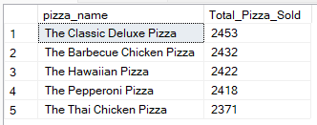

**J. Bottom 5 Pizzas by Quantity**

SELECT pizza_name,sum(quantity)as total_sold_pizza from pizza_data

GROUP BY pizza_name

ORDER BY total_sold_pizza asc

limit 5

***Output***

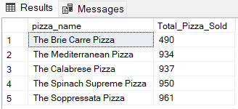

**K. Top 5 Pizzas by Total Orders**

SELECT pizza_name, COUNT(DISTINCT order_id) AS Total_Orders

FROM pizza_data

GROUP BY pizza_name

ORDER BY Total_Orders DESC

LIMIT 5

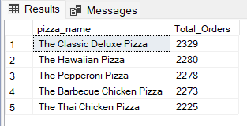

**L. Bottom 5 Pizzas by Total Orders**

SELECT pizza_name, COUNT(DISTINCT order_id) AS Total_Orders

FROM pizza_data

GROUP BY pizza_name

ORDER BY Total_Orders ASC

LIMIT 5

